* [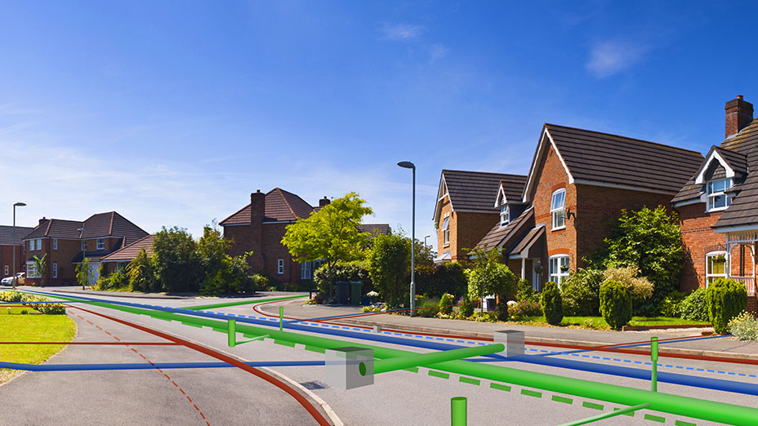](https://www.esri.com/about/newsroom/publications/wherenext/nj-utility-on-forefront-with-new-mixed-reality-application/)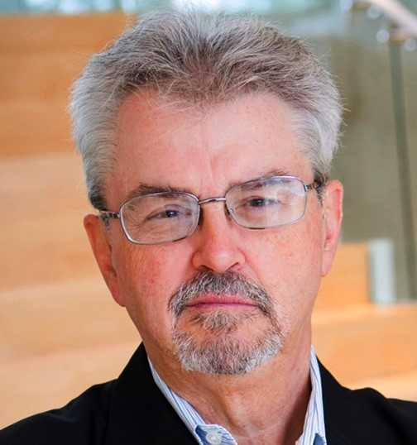

Bill Meehan, Director of   
Utility Solutions for Esri

**Tuesday, March 20, 2018  
5:30 p.m. – 7:30 p.m.**

University of Redlands Main Campus   
**Casa Loma Room**  
Dinner served at 5:30 p.m. Seating Limited, please RSVP.

University of Redlands Main Campus   
Hall of Letters Room 100  
Lunch served at 11:30 a.m.

**RSVP to Ms. Christine Mee at** [**gisab@redlands.edu**](mailto:gisab@redlands.edu)

**By March 12, 2018**

**About the event**

Utilities are undergoing a significant transformation. The challenges are great but so are the opportunities. One way to meet the challenges and leverage the opportunities is embracing technology. Technology alone, however will only go so far. Utilities must rethink their work flows. That is what a digital transformation is all about. This presentation will illustrate the notion of digital transformation and how GIS can be an enabling technology of digital transformation. Examples include utility restoration from recent hurricane devastation.

**Digital Transformation and   
GIS in Utilities**

**Bill Meehan**

**Bill Meehan, P.E. is the world’s leading authority on application of geospatial technology to the electric utility business. Bill is the author of four books, a sought-after speaker and a prominent thought leader within the GIS industry. His blogs have been widely read and he has lectured extensively coupled with teaching courses at Northeastern University and University of Massachusetts. Bill holds a B.S. in Electrical Engineering from Northeastern University and a M.S. in Electric Power Engineering from Rensselaer Polytechnic Institute. Prior to joining Esri, Bill was the Vice President of Electric Operations for a major electric and gas utility. Bill is a registered engineer in the Commonwealth of Massachusetts. And he currently leads the utility marketing practice at Esri.**

**Learn more about the Center for Business GIS**

**and Spatial Analysis**

[**www.redlands.edu/gisab**](http://www.redlands.edu/gisab)

Winter 2018 Speaker Series

**Center for Business GIS**and Spatial Analysis

**Cyrus Shahabi, Ph.D.**

**Cyrus Shahabi** is Professor of Computer Science and Electrical Engineering and the Director of the Information Laboratory (InfoLAB) at the Computer Science Department and also the Director of the NSF's Integrated Media Systems Center (IMSC) at the University of Southern California (USC). He is also the director of Informatics at USC Viterbi School of Engineering. He was the CTO and co-founder of a USC spin-off, Geosemble Technologies, which was acquired in July 2012. Since then, he founded another company, ClearPath (recently rebranded as TallyGo), focusing on predictive path-planning for car navigation systems. He received his B.S. in Computer Engineering from Sharif University of Technology in 1989 and then his M.S. and Ph.D. Degrees in Computer Science from the University of Southern California in May 1993 and August 1996, respectively. He authored two books and more than two hundred research papers in the areas of databases, GIS and multimedia with more than 12 US Patents.